1. Execution sequence of class.

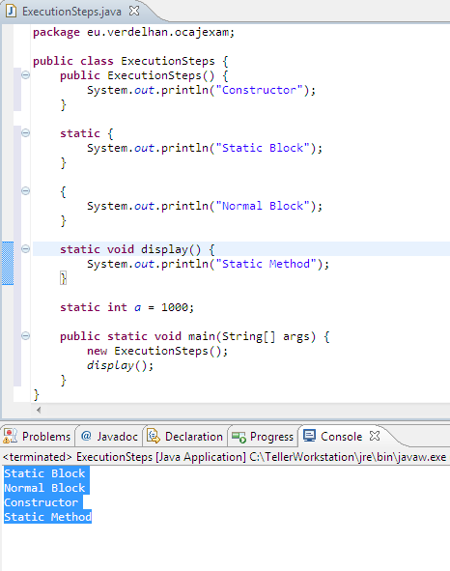

1. How many ways object can be created in java?
   1. <http://javabeginnerstutorial.com/core-java-tutorial/different-ways-to-create-an-object-in-java/>
2. Immutable in java?
   1. <http://javarevisited.blogspot.in/2013/03/how-to-create-immutable-class-object-java-example-tutorial.html>
3. How Hashmap works in java?
   1. <http://javarevisited.blogspot.in/2011/02/how-hashmap-works-in-java.html>
   2. Use of Hash code?
4. What are new feature included in JDK 5 and 6?
5. Collection & Generic
6. String Class & String Pool
   1. <http://javarevisited.blogspot.in/2013/07/java-string-tutorial-and-examples-beginners-programming.html>
7. [What is Daemon thread](http://javarevisited.blogspot.in/2012/03/what-is-daemon-thread-in-java-and.html)?
   1. http://javarevisited.blogspot.in/2012/03/what-is-daemon-thread-in-java-and.html
8. How to terminate JVM in java?
   1. System.exit() and Runtime.Exit();
9. [Difference between ConcurrentHashMap and Collections.synchronizedMap and Hashtable in Java](http://javarevisited.blogspot.in/2011/04/difference-between-concurrenthashmap.html)?
   1. <http://javarevisited.blogspot.in/2011/04/difference-between-concurrenthashmap.html>